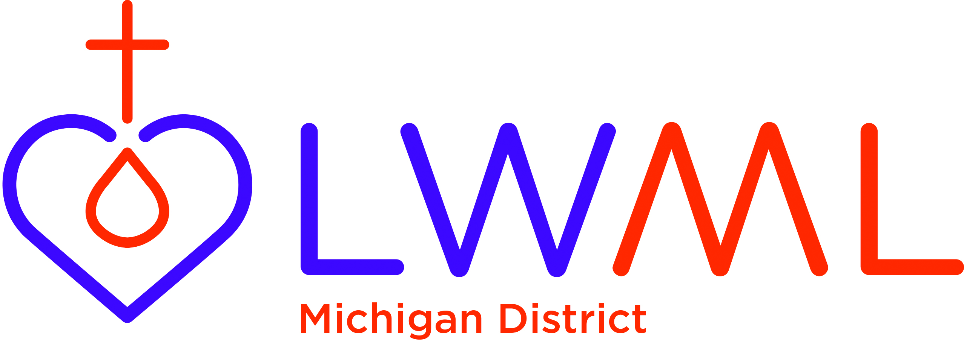
LUTHERAN WOMEN’S MISSIONARY LEAGUE
2020-2022 MISSION GRANT CRITERIA ELIGIBILITY FOR
FEMALE STUDENTS PURSUING STUDIES IN DEACONESS OR OTHER PROFESSIONAL CHURCH WORKER SCHOLARSHIP FORM

- Applicant must be enrolled at one of the Concordia Universities/Colleges of the LCMS System, or at one of the two LCMS Seminaries. Please note that Deaconess Students would qualify under the language of this grant.

- Applicant must be a member in good standing of a Michigan District LCMS congregation.

- Applicant must reside in the State of Michigan as a primary residence (not school address) i.e. parents’ or guardian’s home must be located in Michigan.

- Applicant must intend to go into full-time professional service for the LCMS. (This would include the position of Director of Christian Education).

- This scholarship money will be used towards the cost of the student’s schooling while enrolled as a student in either the Concordia University/College System or for deaconess studies at one of the two Seminaries. The scholarship will be awarded to the student.

- The scholarship awarded will be no less than $500 per academic year per applicant. Reapplication must be made for each new school year. Therefore, in this biennium (2020-2022), a student might receive $1,000 towards their tuition costs; $500 for the 2020-2021 school year and $500 for the 2021-2022 school year.

- Applications must be completely filled out with requested letters of reference and required essay and sent to the Michigan District LWML Scholarship Allocation Committee by November 30, 2020 for the 2020-2021 academic year and April 1, 2021 for the 2021-2022 academic year.

- Application is reviewed and acted upon by the Michigan District LWML Scholarship Allocation Committee Chaired by Michigan District LWML Treasurer. Members of the committee will also include VP of Mission Outreach and the MI District LWML Finance Committee members (including a Pastoral Counselor and the President).

- Those reapplying for the second time within the 2020-2022 biennium do not need to include reference letters with their reapplication forms.

Applications are to be sent to:
Michigan District LWML VP of Mission Outreach
Attn: Sheri Comeford
31501 Cyril
Fraser, MI 48026

Deadlines for applications for this grant money are as follows:
2020-2021 academic year: November 30, 2020
2021-2022 academic year: April 1, 2021

