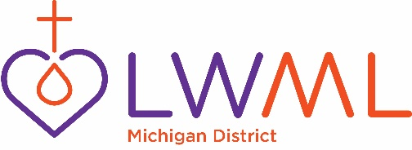
October 10, 2018

Dear Sisters in Christ: (Mentors)
My name is Marilyn Leavens and am the new Leader Development Coordinator for the LWML Michigan District. I am new to this position so we will work together with Christ as our Leader in this new venture. Some of you are seasoned mentors and some are new.
To me, my mentor has been someone I could turn to for any questions I have had and also gives advice on how things are to be done. Mentors are the oil that makes the wheels turn in both the Zone and local Societies. They are Godly women who have had experience in many of the aspects of LWML, and are there to support you as your Mentor.
My personal motto is: GOD FIRST. Take it to the Lord in Prayer. Often an answer will come in a “lightbulb moment”, others in a quiet whisper, or yet still, while studying your Bible. Our seasoned mentors, I am sure, can attest to this, however, if you are still in doubt, give her a call or quick e-mail.
The LWML website has a wealth of information to offer you, and you will find a section on mentoring. It has ideas and suggestions to use within your Zone. I have taken this from the WOMAN TO WOMAN Mentoring Handbook from lwml.org:
“Mentoring is a process of opening and sharing our lives with others. It can be a short term or long-term relationship with another person to help her grow physically, emotionally or spiritually. In some situations we serve as mentors to others, and in other situations we need mentors ourselves. Mentoring does not mean “What can I teach you?” Instead it means, “How can I help you?” Mentors invest themselves in others as Christ’s ambassadors one life at a time. They do not have to be perfect or have all the answers. They do need to take the risk to get involved in someone else’s life for the right reasons. Jesus, our Master Mentor, is involved in our lives. He feels our pains and knows our joys. As mentors, we are not taking the place of Jesus, but we can share our relationship with the Lord with someone else to help her grow in a personal relationship with Him.”
God’s blessings be upon you as you make contact with your zone presidents.
HAPPY MENTORING!
Marilyn Leavens
Leadership Development Coordinator

