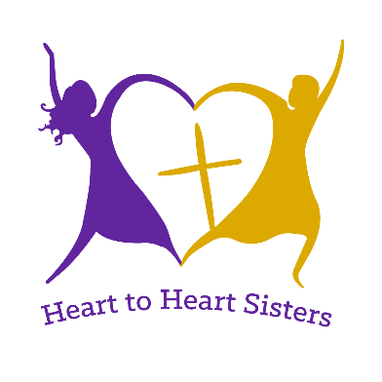
Lutheran Women’s Missionary League
Heart to Heart – SISTERS Of All Nations Application

Michigan District Program

A Heart to Heart Sister is a multicultural woman of The Lutheran Church—Missouri Synod who has a heart for spreading the Gospel to all people and serving the Lord gladly wherever He calls her. If you are selected as a Heart to Heart (H2H), you will be expected to attend all sessions of the LWML district convention as outlined in the H2H Program. After the convention, you will be asked to report to your church and others in your zone about the H2H experience you had.

Name:____________________________________ Nickname: (if any) _______________________________

Street Address: _________________________________________________________________________________________

City, State, Zip Code: _________________________________________________________________________________________

Primary Phone Number: (_______) ______________ Secondary Phone Number: (______) ______________

Email Address: _____________________________________________________________________________

Church Name: _____________________________ Street Address: ___________________________________

City, State, Zip Code: ________________________________________________________________________

Pastor’s Name: ___________________________ Pastor’s Telephone Number: (______) ________________

Pastor’s email: ______________________________________________________________________________

Country of Origin: ___________________________________________________________________________

Describe your involvement at church: _______________________________________________________

______________________________________________________________________________________

______________________________________________________________________________________

Share a little about yourself (family, hobbies, training/education, etc.):

______________________________________________________________________________________

______________________________________________________________________________________

______________________________________________________________________________________

When and how did you become a Lutheran Christian?
______________________________________________________________________________________

______________________________________________________________________________________

______________________________________________________________________________________

To accommodate all multicultural women who speak many different languages, the Heart to Heart Program will be in English. You will also participate in the general convention, which will also be entirely in English.

If selected, are you able to participate in the entire Heart to Heart Sisters Program and convention from June 28, 2024 to June 30, 2024 being held at the Amway Grand, Grand Rapids?

Your convention registration, half of your room, as well as your meal package will be paid by District.

Signature of applicant: _______________________________________ Date: _______________

Please submit this form electronically by April 15, 2024 to Heart to Heart District Leader:

Kimberly Salajan
23000 Clark Rd
Belleville, MI 48111
kimberlysalajan@gmail.com

