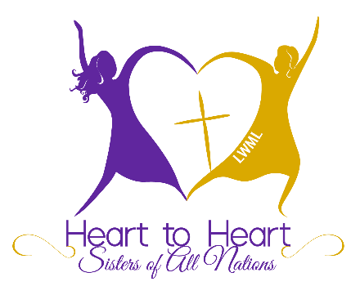

Purpose and What to Expect at Convention

The Heart to Heart — Sisters of All Nations (H2H) program motivates, equips, and provides opportunities for multi-cultural women to serve the Church, participate in LWML, witness to the world, and grow together in relationships as sisters in Christ.

The LWML recognizes there are gifted multicultural women serving with joy and passion in many multicultural ministries throughout The Lutheran Church—Missouri Synod.

The Heart to Heart — Sisters of All Nations district program is an intentional effort to welcome and encourage women of all nations to participate in the life and service of Lutheran Women in Mission (LWML).

These women are already part of an LCMS family and bring vitality and gifts to the life and work of the Church and the LWML. God’s plan is for us to serve Him and the cultures of the world.

The participants should have a good grasp of the English language — both in listening, speaking, and writing.

After the convention the H2H Sisters should be prepared to actively participate in her LWML group and zone. She may also be asked to share your faith stories at rallies, retreats, and other events. Her mentor could provide support and encouragement in preparing this.

Registration, meals, and one-half of their hotel room will be paid for by District. We no longer have a mentor program but encourage someone to accompany them to the convention.

