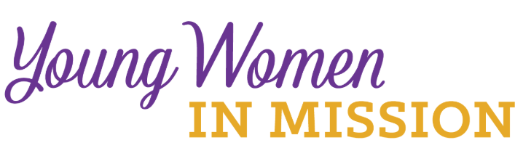
Young Woman Representative Application
Convention: Michigan District Date: June 28-30, 2024

Convention Location: Amway Grand, Grand Rapids, Michigan
Complete and return this form postmarked no later than
January 31, 2024

To your Zone President:

Address:
Phone:
E-mail:

Name_____________________________________ Age ______________
Address _____________________________________________________
City _____________________________ State _________ Zip ___________
Occupation ____________________________________________________
Home Congregation ____________________ City ________________

Zone_________________________________________________________
Phone _______________________ Email _________________________
Please answer the following questions. Use a separate sheet of paper if needed. Return the completed form to your Zone president (see above).
1) The LWML motto is “Serve the Lord with Gladness” (Psalm 100:2). How do you do this in your life?
2) What groups and activities are you involved in or have you been involved in at your church?
3) What do you know about the LWML? Have you been involved at any level?

4) Why do you desire to be a Young Woman Representative for the district?
5) What do you feel your special interests, talents, and gifts are?
6) Will you commit to serve in some capacity in your district after the convention?

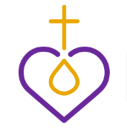
Please ask someone who knows you well, perhaps the person who encouraged you to apply, to answer the following question, “Why do you feel this woman would make a good LWML Young Woman Representative?”

Ask this person to answer on a separate sheet of paper and include their name and relationship to you. Attach their sheet to your application form.

7) Submit your application to the Zone President.

Thank you for considering to attend the District Convention as a YWR.

